Human Right #5
No Torture (Arial 24)
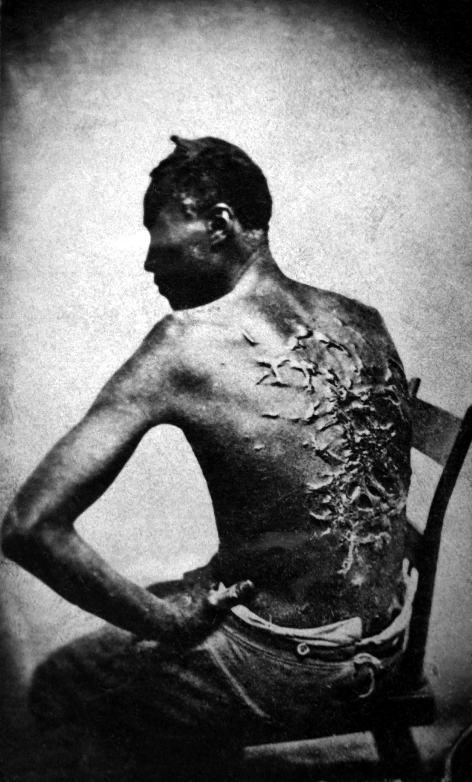

Jaimie Eynon (Arial 24)
Period: B3
March 17th, 2017

Table of Contents (18 font)

What is Torture? (your descriptive paragraph)………………...……..Page 2

The Effects of Torture (cause and effect)............................………...Page 3

ISIS vs. Christians (compare and contrast)...................................…Page 4

The Lost Boys of Sudan (problem/solution)......................................Page 5

Facts about Torture (sequential).....………………...…………...…....Page 6

Charts and Graphs about Torture.………..…………………………...Page 7

Glossary…………………………………………………………………..Page 8

About the Author…………………………………………………………Page 9

Works Cited………………………………………………………………Page 10

(14 font)

What is Torture? (24 font)

The webster dictionary describes torture as, “The action or practice of inflicting severe pain on someone as a punishment or to force them to do or say something, or for the pleasure of the person inflicting the pain.” What this means is that the purpose of torture is to hurt another person to either cause happiness or joy to the person torturing, or to get some sort of means from the torture. Torture can happen in many different ways. It can be physical, but it can also be emotional. Oftentimes people will hurt others by killing their family members and making the person being tortured watch. This is one of the most severe types of mental punishment that one could go through. (14 font)

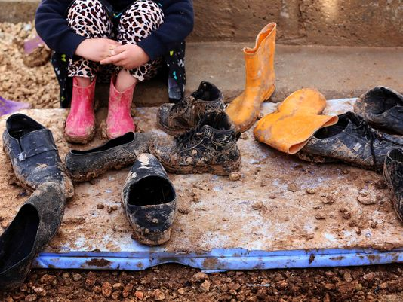
This is an image of a little girl whose family was tortured and killed by ISIS. These shoes belong to her dead family members.

The Effects of Torture (Bold 24)
Imagine being beaten by a parent day in and day out. Everything you do is wrong. If you look wrong, you get hit. If you say something wrong, you get smacked. Although the physical torture hurts you, nothing can compare to the yelling that you constantly get. You are hurt, defeated. You have no self-confidence left. Your self-esteem goes down, and because of this, so do your grades. You have nowhere to run. The people who should be taking care of you, abuse you. According to the International Rehabilitation Center for Torture Victims, “Torture victims often feel guilt and shame, triggered by the humiliation they have endured. Many feel that they have betrayed themselves or their friends and family.” Not only are you hurt by the torture and words that have been said to you, you believe it. You believe that you are bad and that you made a mistake. The effects of torture not only hurt you physically, they hurt you mentally. (14 font)

Did you know that over 3 million reports of child abuse are made each year? That means a report is made every 10 seconds!

Where to Go For Help (Bold 16)

If you are being tortured, remain calm, assess the situation, find the best plan to leave the torturer, and call 911. If you are scared to call the police and fear that you could get in worse trouble, talk to a trusted adult or friend who can help you.

ISIS vs. Christians (Bold 24)

Although both ISIS and Christians are religious sects, their religious views differ greatly. For example, ISIS worships their prophet Mohammed and believe that Christ has not yet come. Christians on the other hand believe that Christ has come. Because of their differences, ISIS has a plan to torture Christian’s for not believing the same things that they do.

Torture Chambers in Christian Churches (16 bold)

Today ISIS is taking over as many Christian churches that they can and using these churches as torture chambers. Here, they are forcing people to join their muslim religion. Those who refuse to join are killed.
Clearly their tactics of getting people to join is unethical and violates their Human Rights.
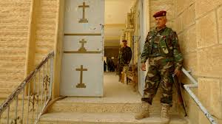

This picture shows a member of ISIS guarding what was once a Christian church and is now a Christian Torture chamber.

The Lost Boys of Sudan (Bold 24)

Problem: Sudan is a worn torn country located on the content of Africa. The country is going through religious battles between the Muslims and Christian people. The lost boys of Sudan are a group of boys who had to flee their country because it was invaded by Muslims who planned to kill them in fear that they would one day revolt and fight against them. The only option for the Sudan boys was to find a new place to live. They walked many miles to Ethiopia with no food and water. They faced many trials on their journey, such as Lions, swimming through crocodile infested water, being shot at, homesickness, and much more.
Solution: The solution for these boys who have gone through so many trials was for them to become citizens of a new country. The United States of America took in nearly 4,000 of the boys and made the US citizens. Many other countries have also taken in Sudan refugees. The boys who came into these new countries are very excited to be educated so that they can go back to the Sudan and help others who are in similar situations like they are.

Facts About Torture

According to the New Internalist Magazine, the leading targets of torture today are:

- Persecution (including torture and rape) against Tutsis by the Government and its supporters continues in the Democratic Republic of Congo.

- Roma communities were singled out in Kosovo, Bulgaria, the Czech Republic, Greece, Hungary, Romania and Slovakia. Kurds bore the brunt of Turkish torture.

- Race continues to be the predominant factor determining police torture and killings in Europe and the U.S.

- The most vulnerable - indigenous people, street children and migrant workers continue to be targeted in Brazil, Colombia, Honduras, and Mexico.

- Women live in a state of torture in Saudi Arabia, Afghanistan, and Pakistan, with their lives dictated by and in the hands of men. ‘Honour’ killings of women in Pakistan have escaped prosecution, with even victims of rape being killed for bringing ‘dishonour’. The killing of female relatives suspected of adultery has legal sanction in Jordan.

- ‘Disposables’ - ie homosexuals, prostitutes, petty criminals, drug dealers and vagrants are targeted by death squads in Colombia.

- In El Salvador last year gay men were beaten and killed by the police. No-one was prosecuted.
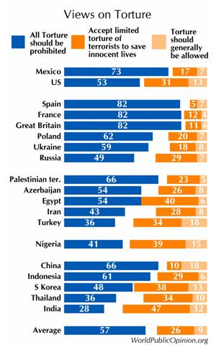
Charts and Graphs (Extra Credit Page)

This graph shows the views on torture for different countries around the world.

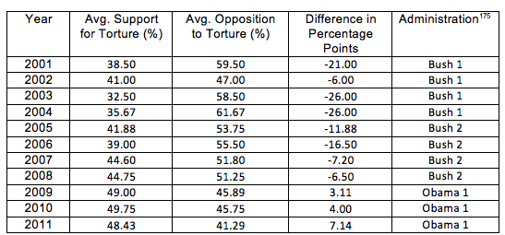

This chart shows the support, opposition, and difference in percentage under different presidential Administration from 2001-2011

Glossary (Words in alphabetical order)

Mohammed - Believed by Muslims to be a messenger. While non-Muslims generally regard Muhammad as the founder of Islam, Muslims almost universally view him as the last prophet sent by God to mankind and jinn, and the restorer of the unaltered original monotheistic faith of Adam, Abraham, Moses, Jesus, and other prophets and Islam.

Persecution - Hostility and ill-treatment, especially because of race, political or religious beliefs.

Punishment - Causing or characterized by harsh or injurious treatment; severe; brutal: “The Storm was accompanied by punishing winds.”

Self-Confidence - Realistic confidence in one’s own judgment, ability, power, etc.

Vulnerable - Susceptible to physical or emotional attack or harm.

About the Author

Jaimie Eynon is an English teacher at Lehi Junior High. She recently married the love of her life in 2014 and currently enjoys spending time remodeling her new house. Among other things, she is a Charles Dickens loving, Little Mermaid watching, snowboarding, chicken and dumplings eater, who loves the color yellow, dogs, Christmas, garage sales, boat rides, cooking, traveling, geeky nerd conventions, and watching movies with her husband.

She chose to learn about Human Right #5 because torture towards others in her opinion, is one of the most cruel forms of harm that can happen in the world today. By learning more about torture, she hopes to share with others the harms that come by hurting another. She hopes that one day there will be a world where all of the Human Rights are kept in all countries.

You can read more about this here

