Planning Out a Story

Directions: Pick three different ways to plan out a story from the examples below. Use one for each of the three brainstorming or journal entry ideas to start organizing your own story. As you plan a short story, remember to focus on only one event (maybe two). Focus on writing in detail instead of writing about a lot of events. You will use three pages in your writer’s notebooks today. Label the pages Story Organization 1, Story Organization 2, and Story Organization 3.

Travelogue - Write down in a page, all the events that will happen in your story, with details, thoughts on characters, and anything else that comes to mind.

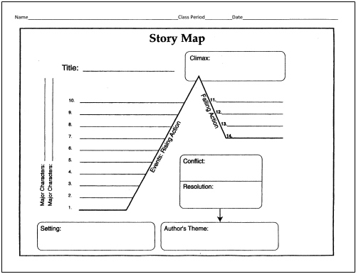
Sticky notes on desks - Write main events for your story on sticky notes, then stick them to your desk. Use a dry erase marker to draw arrows connecting them in the order they will happen. Once you have your final order, put that in your writer’s notebook.

← Story map - Make a map of your story with an exposition (intro part where we get to know the characters), inciting incident (something that gets the story rolling), rising action (events or details that makes things more intense), climax (the turning point in the story), falling action (the last few events), and resolution (where the conflict is solved).

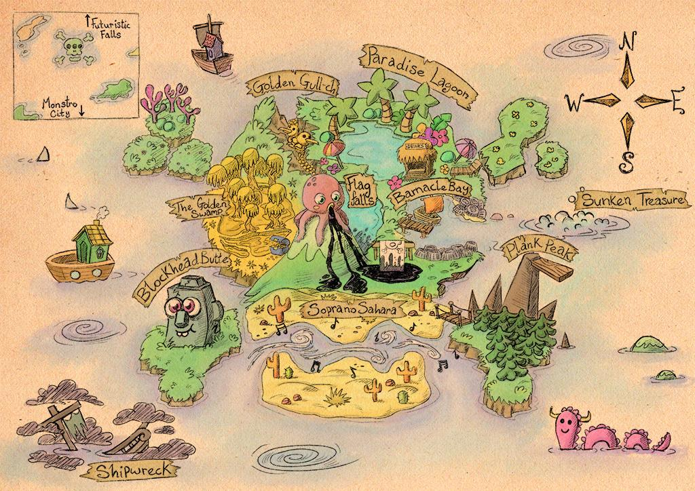
← Create a map or setting drawing - Draw a map or picture related to the setting of your story.

Outline (Roman numerals, numbers, etc.)
- The high dive
  - The community swimming pool
    - Blue water
    - Kids screaming
  - The high dive
    - Feels so high
    - My brother mocking me
      - Made me want to
prove that I’m not a baby

Plan from the ending - If you know how you want the story to end, then figure out what needs to happen to reach that point. You can use cause and effect. This happened because of this, etc.

Beginning, middle, and end - Begin writing out paragraphs for what happens at the beginning, middle and end of the story. Y0u will have three complete paragraphs for this page in your writer’s notebook.

Have a basic idea of where you’re going and just start writing - Some writers just like to start their stories when inspiration comes to them. For this organization page, begin writing out your story.
← Mind maps - Draw circles containing main ideas, characters, or other details from your story. Draw lines connecting the ideas that are related to each other.

Mind vomit - Just write down everything that comes into your head, regardless of whether or not it makes sense. You can find the good ideas and fill in the holes later.

Plan as you go - Write a few paragraphs, then plan what will happen next, then write a bit more. Repeat.

Dialogue- Just start writing down dialogue (conversations) between characters in your story. Fill it in later with actions and details.
“What are you thinking?”
“Just how I’m going to take over the world.”
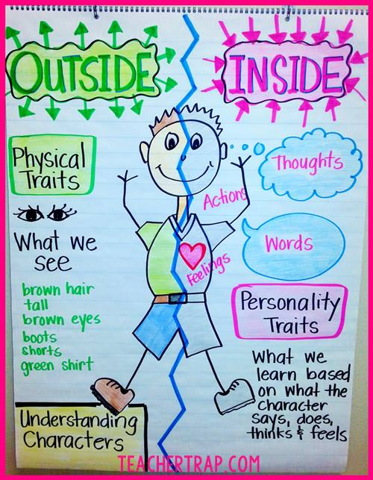
← Character’s desires, conflict, and drawings - Draw a picture of your main character(s). On one side list what this his/her physical characteristics are and how he/she is viewed by others. On the right side list what this person is like on the inside. Or write down what they want more than anything else (in your story).

Sketch it out - Draw out your story in your notebook.

Make your characters suffer - Ask the question, “How can things get worse?” or “What is the worse thing that could happen to my character right now?” Then make it happen. Be merciless!

↓Storyboard- Use frames to draw sketches of your story, similar to a comic. Under the frames, write short descriptions of what is happening.

