Name ____________________________ Period_______

Rules for Quotation Marks
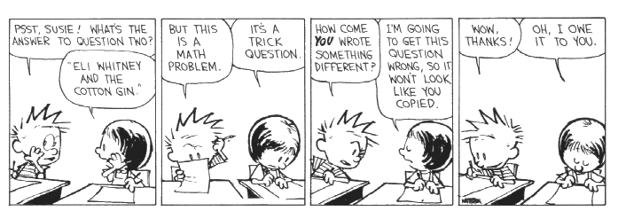
Instructions: Looking at the examples below each rule, fill in the blanks with the correct answer.
Rule #1: Use quotation marks __________ and __________ a direct quote. (A direct quote is exactly what someone says.)  “Psst, Susie! What’s the answer to question two?”  “Eli Whitney and the cotton gin.”  Rule #2: Use a comma to separate a phrase such as he said from the quote itself. This is called a dialogue tag. Place the comma __________ the quotation marks. Put a period after the _______.  Calvin looked down at his paper, scratching his head with his pencil. “But this is a math problem,” said Calvin.  “It’s a trick question,” replied Susie, still writing. | Rule #3: Place the end punctuation __________ the  closing quotation mark.  Calvin raised an eyebrow, then asked suspiciously, “How come you wrote something different?”  “I’m going to get this question wrong,” Susie said wisely. “So it won’t look like you copied.”  Rule #4: Start a new _______________ and indent when  a different person starts talking.  → “Wow, thanks!” yelled Calvin. He began writing again with  a smile on his face.  → “Oh, I owe it to you,” said Susie.

Practice! Write out the dialogue for the comics below. Make sure you follow the rules on the previous page.
    

