Text Features
Name: _________________________
Class: __________________________
Monkeys

1.

Mm MM
2.

A monkey is a primate, either an Old World monkey or a New World monkey. There are about 260 known living species of monkey. Many are arboreal, although there are species that live primarily on the ground, such as baboons. Monkeys are generally considered to be intelligent. Unlike apes, monkeys usually have tails. Tailless monkeys may be called "apes", incorrectly according to modern usage; thus the tailless Barbary macaque is called the "Barbary ape".
3.

Did you know?
Did you know that when monkeys yawn it's sometimes because they are tired, and sometimes because they are mad?

4.

Characteristics
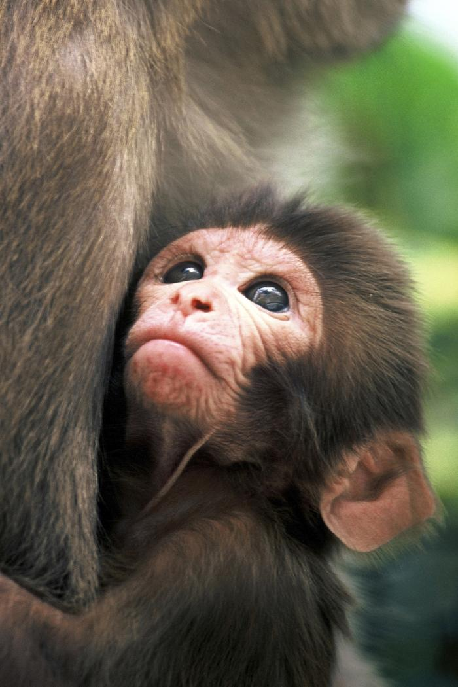
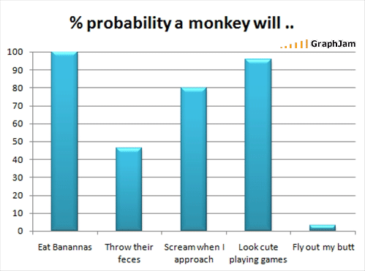
Monkeys range in size from the Pygmy Marmoset, at 140 to 160 millimeters (5–6 in) long (plus tail) and 120 to 140 grams (4–5 oz) in weight, to the male Mandrill, almost 1 meter (3.3 ft) long and weighing 35 kilograms (77 lb). Some are arboreal (living in trees) while others live on the savanna; diets differ among the various species but may contain any of the following: fruit, leaves, seeds, nuts, flowers, eggs and small animals.
5.

Primate: a mammal of the order of Primates
Species: a class of individuals having some common characteristics or qualities.
Arboreal: living in trees

9.

6.

7.
8.

A baby monkey holding tight to her loving mother

