Name: ________________________________________ Period: _______________

Text Structures

Directions: Follow along with the Prezi and fill in the blanks.

1. There are five main patterns for expository texts. They are:
·
·
·
·
·

2. This type of text structure features a ________________________ description of something to give the reader a ____________________ picture.

3. In cause and effect, the _______________________ is told the result of an event or occurrence and the _____________________ it __________________________.

4. Texts that follow the compare and contrast structure tell about the
__________________________ and _____________________________ of two or more objects, places, events or ideas by ____________________________ their traits for ______________________________.

5. Texts that follow the order and sequence structure tell the __________________ in which _________________ in a process or series of events ________________.

6. This type of structure sets up a _____________________, explains the ____________________, and then discusses the _____________________ of the solution.

Directions: Identify the text structure from the paragraphs that follow.

7. 8.
9. 10.
11.

Directions: Write the name of the text structure by the graphic organizer that it corresponds with.
12.  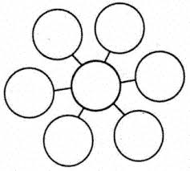 | 13.  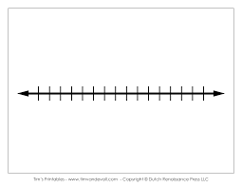 | 14.  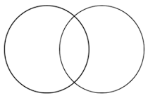
15.  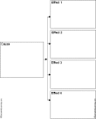 | 16.  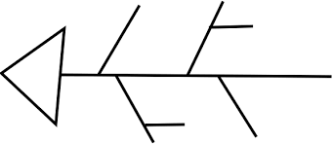 | Blank Box

Directions: For each text structure, list possible transition words that correspond to that form of writing.

Text Structure | Possible Transition Words
Compare and Contrast | 17.
Descriptive | 18.
Cause and Effect | 19.
Problem/Solution | 20.
Sequential | 21.

